Directorate of
Public Health

2021 Census Bolton
Summary briefing: Economic activity and travel to work

Prepared by: Bolton Council Intelligence Hub in collaboration with BRAIN

Date: 13/01/2023

Summary briefing: Economic activity and travel to work overview

Purpose
This report details Bolton’s economic activity and travel to work data for Bolton, as recorded on the Census 2021 (data release 08/12/2022).

Scope
The Office for National Statistics (ONS) released further data from the Census 2021 on the 8th December 2022, covering economic activity and methods used to travel to work. This briefing paper will cover an overview of the data release. Briefings on each of these separate data sets are also available in the New and notable section of the Bolton JSNA.

Key findings

Economic Activity
- Census 2021 took place during the coronavirus (COVID-19) pandemic, a period of unparalleled and rapid change; the national lockdown, associated guidance and furlough measures will have affected the labour market topic. Caution should be taken when using these data for planning and policy purposes.
- The economically active population includes people who were put on furlough at the time of Census 2021, who were considered to be temporarily away from work.
- At Census Day, 21 March 2021, 134,542 usual residents aged 16 years and over in England and Wales were economically active (57.9%), while 97,751 (42.1%) were economically inactive.
- Among usual residents of Bolton aged 16 years and over, 45.9% (or 106,658) were employees, almost 8% (18,571) were self-employed and a further 3.9% (9,103) were unemployed but looking for work.
- Over a fifth of usual residents aged 16 years and over were economically inactive because of retirement (21.1%, n= 48,899); a further 6.4% (14,930) of residents aged 16 years and over were economically inactive due to looking after home or family, 5.5% (12,682) due to studying and 5.4% (12,638) were on long-term sick or disabled.
- Of those aged 16 years and over in employment, 8% worked 49 or more hours a week; 9.4% working 15 hours or less a week both lower than the proportion observed nationally.
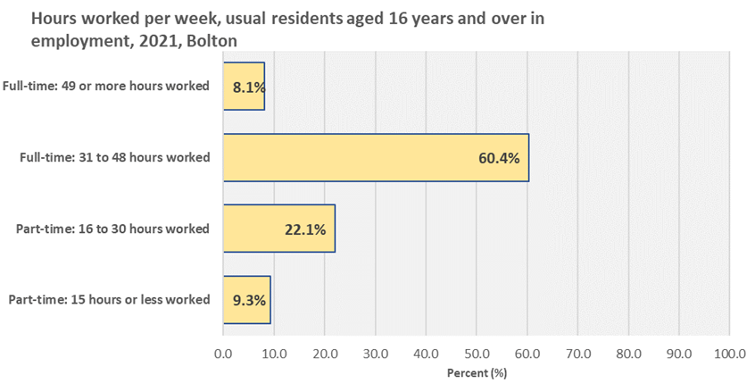
- In Bolton, a larger percentage of the usual resident population aged 16 years and over not in employment had never worked (33.4%) than in England (25.6%) and the percentage who last did paid work more than 12 months ago was lower in Bolton (55.8%) than in England (61.1%).
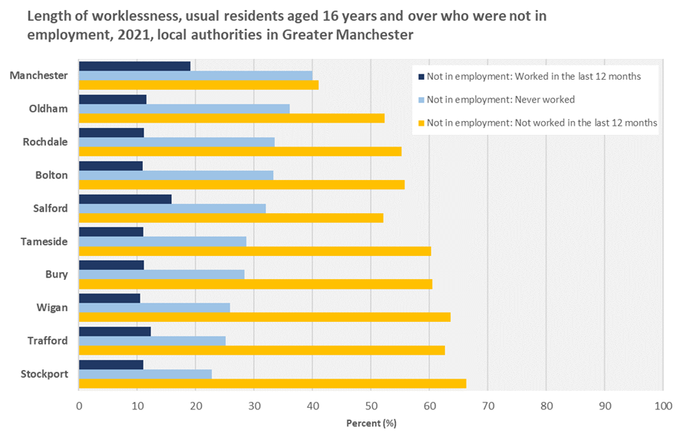
- Within Greater Manchester, Manchester was the local authority with the largest percentage of usual residents aged 16 years and over not in employment who had never worked (39.9%) and the smallest percentage who last did paid work more than 12 months ago (41%).

Travel to work
- Census 2021 estimates that 29,568 (23.6%) usual residents aged 16 years and over in employment in Bolton worked mainly at or from home in the week before Census Day, 21 March 2021.
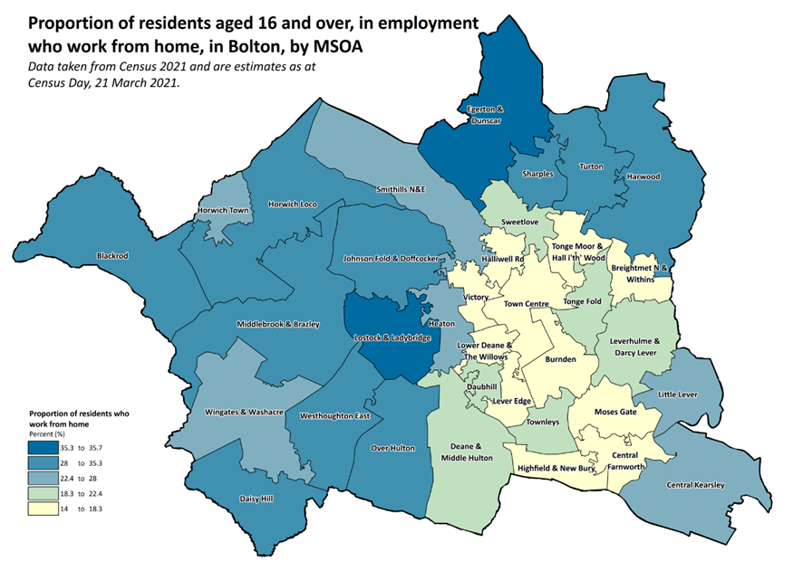
- Just over three quarters of usual residents aged 16 years and over in employment (76.4%; n=95,871) gave a work base other than “at or from home”.
- The most selected mode of travel to work was driving a car or a van (54.1%, 67,803 of all usual residents aged 16 years and over in employment).

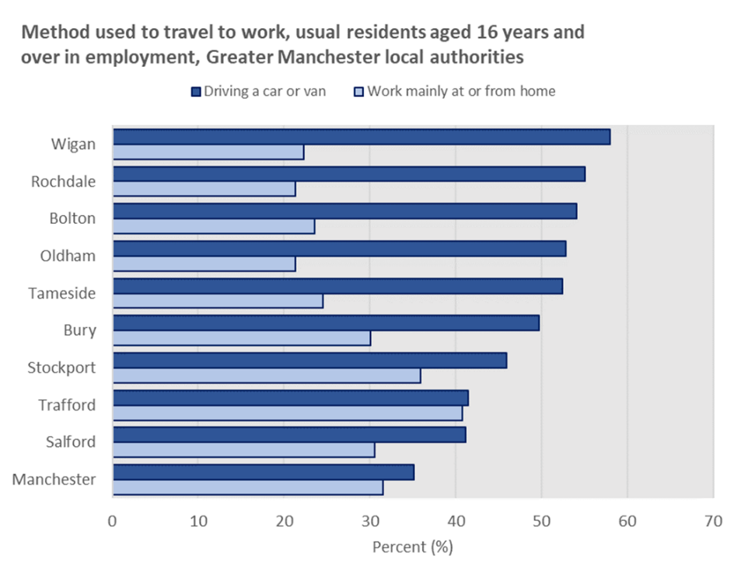
- A large proportion of usual residents aged 16 years and over in employment in Bolton travelled between 2km and 5km to work (16.2%); this was followed by 5km to less than 10km (14.1%) and 12.1% of the working population travelling less than 2km to work.

Useful links

Economic activity status, England and Wales - Office for National Statistics (ons.gov.uk)

Travel to work, England and Wales - Office for National Statistics (ons.gov.uk)

New and notable – Bolton JSNA – this and all future census briefings will be available here with local interpretation. A working group of multi-agency partners is developing more bespoke analysis and intelligence to inform Bolton priorities

