Directorate of
Public Health

2021 Census Bolton
Summary briefing: Education

Prepared by: Bolton Council Intelligence Hub in collaboration with BRAIN

Date: 30/01/2023

Summary briefing: Education

Purpose
This report details the Education Census 2021 information summary for Bolton (data release 10/01/2023).

Scope
Respondents were asked if they were in full-time education on Census Day, 21 March 2021 (this includes schoolchildren and adults in full-time education) and also asked to determine the residents’ highest level of qualification.

Residents of England and Wales aged 16 years and over were asked to record any qualifications (including academic, vocational, and professional qualifications) they had achieved in England, Wales or worldwide. This was used to calculate the highest level of qualification (so, the highest level of qualification that an individual reported irrespective of previous qualifications listed) using the following categories:

- no qualifications: no formal qualifications

- Level 1: one to four GCSE passes (grade A* to C or grade 4 and above) and any other GCSEs at other grades, or equivalent qualifications

- Level 2: five or more GCSE passes (grade A* to C or grade 4 and above) or equivalent qualifications

- apprenticeships

- Level 3: two or more A Levels or equivalent qualifications

- Level 4 or above: Higher National Certificate, Higher National Diploma, Bachelor's degree, or post-graduate qualifications

- other qualifications, of unknown level

Key findings
In Bolton, there were 62,169 (22.4%) schoolchildren and full-time students in 2021, out of a total 277,505 usual residents aged five years and over. This was slightly higher than the average for Greater Manchester (22%).

Unsurprisingly, Manchester was the only outlier across the region with a significantly greater proportion of students aged 5 and over; 30.2% (n=156,241) being classified as schoolchildren or full-time students. Oldham (23.9%) had the second largest proportion in the conurbation and Wigan (18.2%) had the lowest proportion.

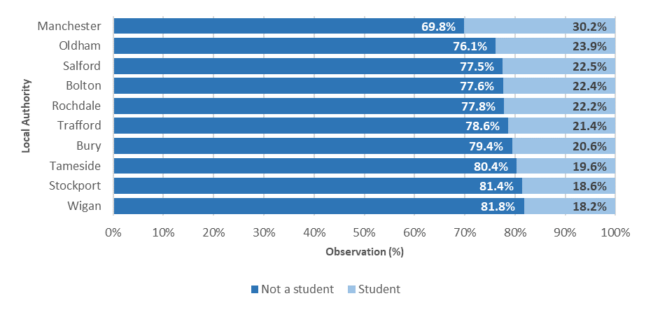

In Bolton, 27.4% of usual residents aged 16 years and over (n=63,678) indicated that their highest level of qualification was at Level 4 or above.

The second most common category was no qualifications (22.6%, 52,451); this was higher than the proportion seen nationally (18.2%).

Apprenticeships were the highest qualification for 6.2% (n=14,327) of people.

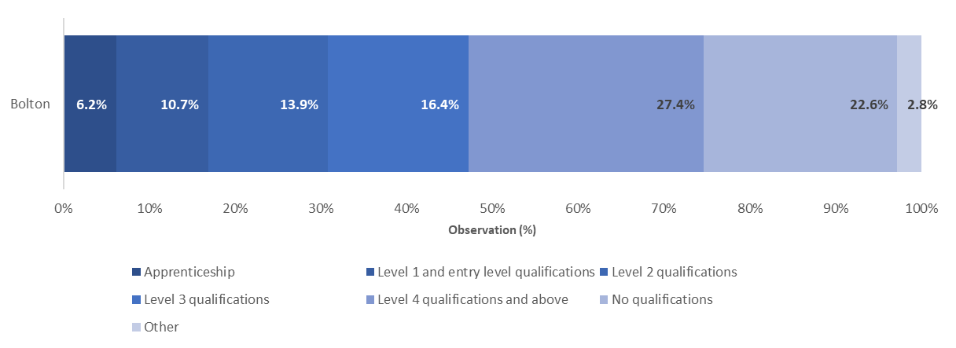

Although highest level of qualification is broadly comparable between 2011 and 2021, there are caveats. The categories remain the same as they were in 2011 and are derived in the same way, however the way the questions were structured and how the respondent was routed in the qualification questions changed substantially from 2011.

These changes to the collection methodology mean that a reasonable proportion of respondents will have identified a different qualification level than they did in 2011 even though they still hold the same qualifications. Therefore, any change in qualification levels when compared with 2011 will be partly a result of the methodology changes and be partly indicative of real change. ONS advise interpreting these with caution, avoid drawing conclusions from the differences or using them to inform planning or evaluate policies. As such, comparisons with 2011 Census have not been included in this briefing.

Across Greater Manchester, Trafford had a highest percentage of people who indicated their highest level of qualification was Level 4 or above (43%, 79,961), whereas Tameside had the lowest percentage in the conurbation (24.4%, 45,214).

Oldham had a higher proportion of people indicating no qualifications (24.7%, 46,208); Wigan had the highest proportion of residents who reported an apprenticeship as their highest level of qualification (7.1%, 18,997).

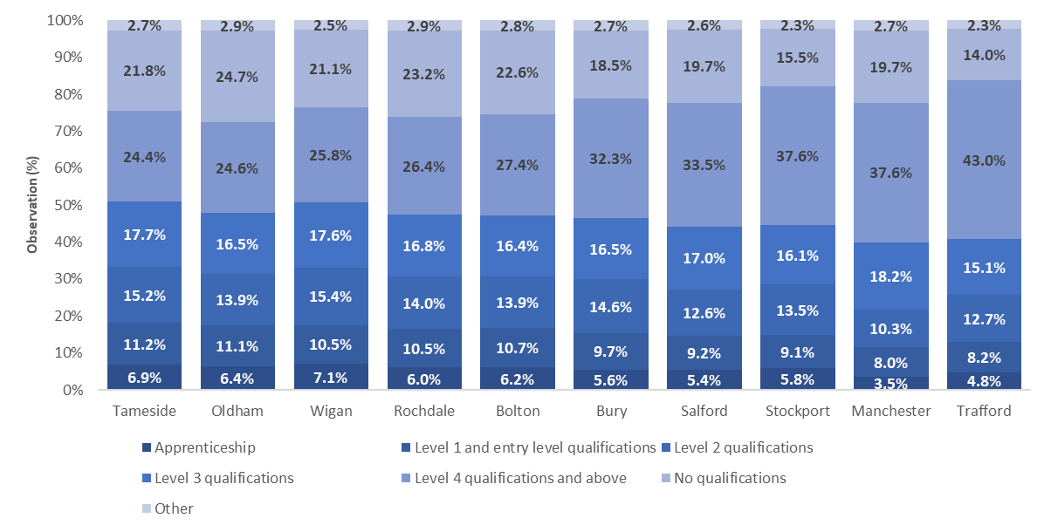

Useful links

Education, England and Wales - Office for National Statistics (ons.gov.uk)
Census Maps - Census 2021 data interactive, ONS
Build a custom area profile - Census 2021, ONS
How life has changed in Bolton: Census 2021 (ons.gov.uk)

New and notable – Bolton JSNA – this and all future census briefings will be available here with local interpretation. A working group of multi-agency partners is developing more bespoke analysis and intelligence to inform Bolton priorities

