Directorate of
Public Health

2021 Census Bolton
Summary briefing: Unpaid Care

Prepared by: Bolton Council Intelligence Hub in collaboration with BRAIN

Date: 23/01/2023

Summary briefing: Unpaid Care

Purpose
This report details the Unpaid Care Census 2021 information summary for Bolton (data release 19/01/2023).

Scope
Respondents were asked "Do you look after, or give any help or support to, anyone because they have long-term physical or mental health conditions or illnesses, or problems related to old age?". Anyone who answered yes was asked to select a category that best corresponded to the number of hours of unpaid care a week. People were asked to exclude any care they provided as part of any paid employment. The wording was changed from 2011 where the Census asked "Do you look after, or give any help or support to family members, friends, neighbours or others".

Percentages in this paper have been age-standardised. Health and age are closely related, with older people being more likely to be in poorer health. Age-standardised proportions (ASPs) account for different age structures in populations and are more appropriate than crude percentages when drawing comparisons over time and across areas with different age profiles. Where numbers are reported these are the actual number who responded in each category.

Census 2021 was undertaken during the coronavirus (COVID-19) pandemic, which may also have influenced how people perceived and undertook their provision of unpaid care and therefore may have affected how people chose to respond.

Key findings
9.8% (25,980) of respondents in Bolton said that they provide between 1 and 50 hours of unpaid care per week. 4.3% (11,477) provide between 1 and 19 hours of unpaid care, 2.2% (5902) provide between 20 to 49 hours of unpaid care and 3.3% (8601) provide 50+ hours of unpaid care.

This is slightly higher than the North West 9.7% (4.5% 1-19 hours, 2.1% 20-49 hours, 3.1% 50+ hours) and higher than England and Wales 9.1% (4.4% 1-19 hours, 1.9% 20-49 hours, 50+ hours).

When compared with its Greater Manchester neighbours, Bolton has the joint 2nd highest proportion of its population providing unpaid care alongside Oldham (9.8%, 4.1% 1-19 hours, 2.3% 20-49 hours, 3.4% 50+ hours). Wigan has the highest (10.1%, 4.4% 1-19 hours, 2.3% 20-49 hours, 3.4% 50+ hours). Manchester and Trafford had the joint lowest proportion.

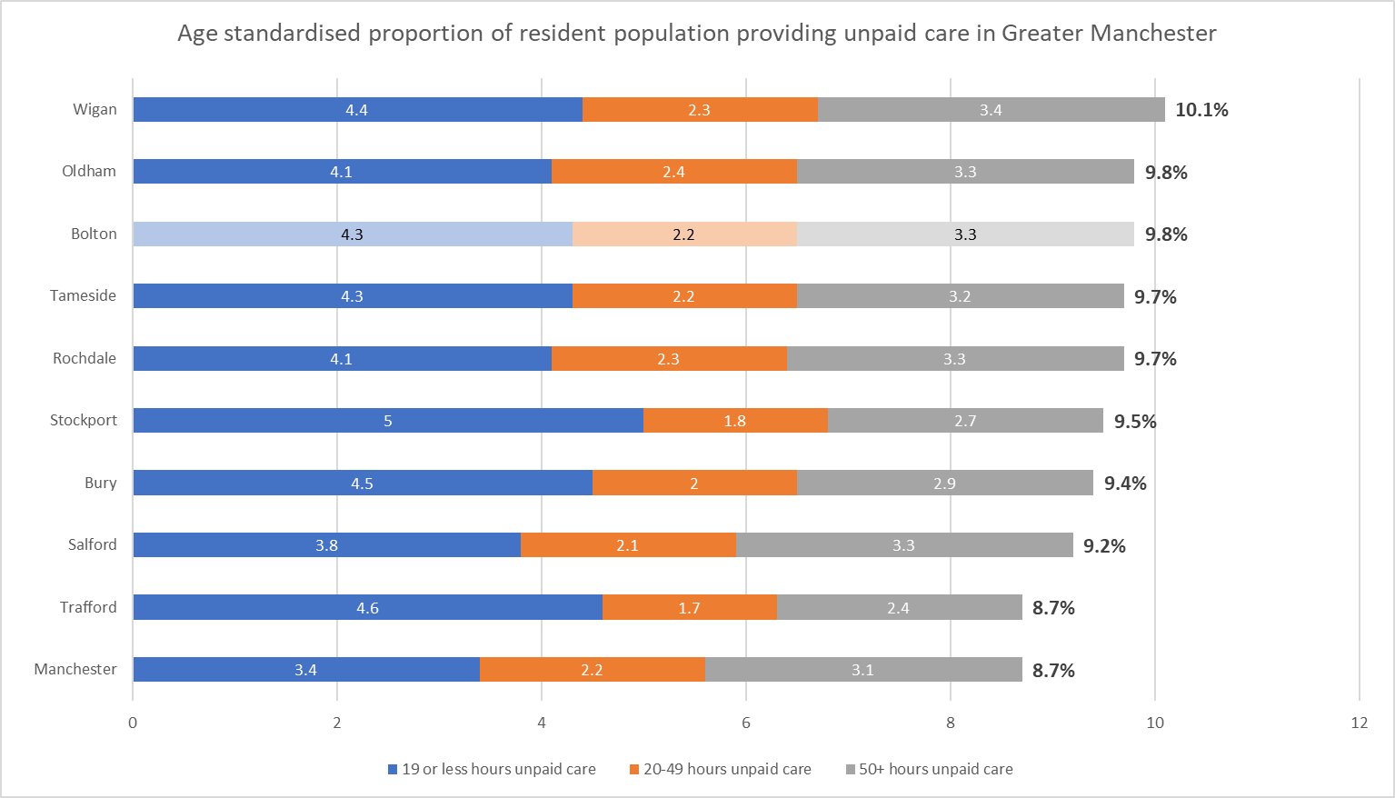

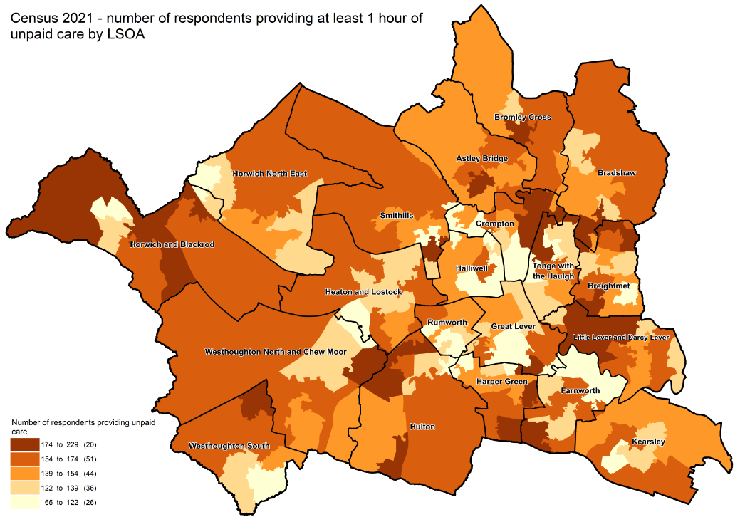

This proportion of people providing 1-19 hours of unpaid care has decreased by 2.9 percentage points since 2011, from 7.2% to 4.3%, however there has been an increase in the proportion of people providing 20-49 hours of unpaid care from 1.8% to 2.2%, whilst the proportion of people providing 50+ hours has remained at 3.3%. This has resulted in an overall reduction of 2.5 percentage points. Similar decreases in people providing 1-19 hours of unpaid care can be seen across the North West (2.7 percentage points from 7.2% to 4.5%) and in England and Wales (2.8 percentage points from 7.2% to 4.4%).

Potential explanations for the changes in the provision of care could include;
- Coronavirus guidance on reducing travel and limiting visits to people from other households.
- Unpaid carers who previously shared caring responsibilities may have taken on all aspects of unpaid care because of rules on household mixing during the coronavirus pandemic.
- There were a higher number of deaths than expected in the older population at the beginning of 2021 due to coronavirus (COVID-19) and other causes; this could have led to a reduction in the need for unpaid care.
- Changes in the question wording between 2011 and 2021 may have had an impact on the number of people who self-reported as unpaid carers.

Useful links

General health, England and Wales - Office for National Statistics (ons.gov.uk)
Census Maps - Census 2021 data interactive, ONS
Build a custom area profile - Census 2021, ONS
How life has changed in Bolton: Census 2021 (ons.gov.uk)

New and notable – Bolton JSNA – this and all future census briefings will be available here with local interpretation. A working group of multi-agency partners is developing more bespoke analysis and intelligence to inform Bolton priorities

