Directorate of
Public Health

2021 Census Bolton
Summary briefing: General health

Prepared by: Bolton Council Intelligence Hub in collaboration with BRAIN

Date: 23/01/2023

Summary briefing: General Health

Purpose
This report details the General Health Census 2021 information summary for Bolton (data release 19/01/2023).

Scope
Respondents were asked to assess their general health on a five-point scale: "Very good", "Good", "Fair", "Bad", or "Very bad."

Health and age are closely related, with older people being more likely to be in poorer health. To account for different age structures in populations age-standardised proportions (ASPs) are used throughout this paper; they allow for comparison between populations over time and across geographies, as they account for differences in the population size and age structure. The numbers being reported here are the actual number who responded in each category.

Key findings
In Bolton 45.5% of people reported very good health (142,076). This is lower than the value for England and Wales (47.5%) and the North West (46.8%). Bolton ranks 5th in Greater Manchester, behind Trafford (51.5%), Stockport (49.3%), Bury (46.9%) and Wigan (45.9%). The lowest in Greater Manchester was Manchester (43.2%) followed by Oldham (43.4%)

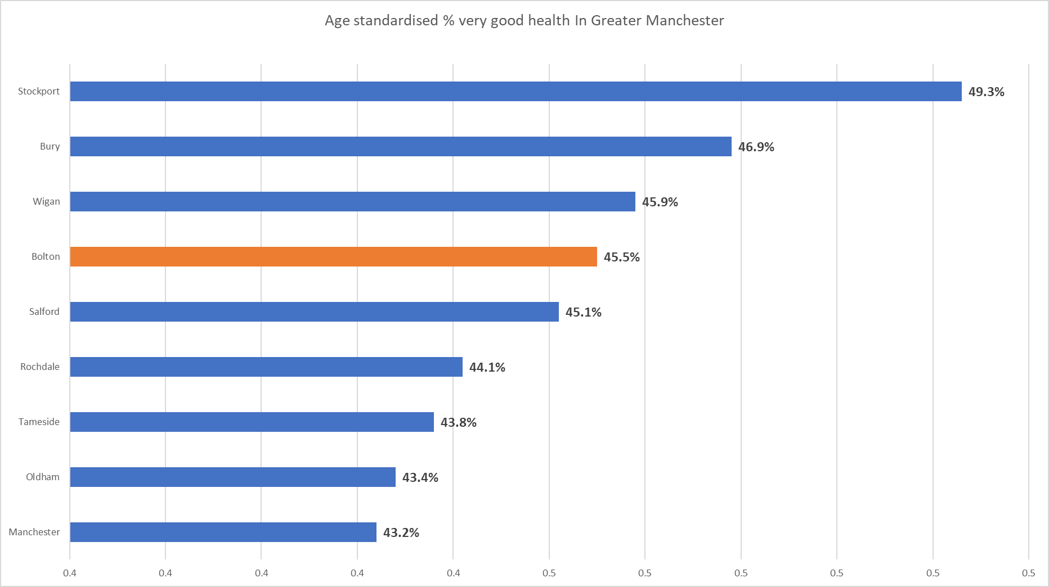

In Bolton 6.7% (18,197) of people reported either bad health (5.1%, 13,968) or very bad health (1.6%, 4229). This was a higher proportion than England and Wales (5.4%) and the North West (6.4%). Bolton again ranks 5th in greater Manchester behind Trafford (4.8%), Stockport (5.2%), Bury (5.8%) and Wigan (6.3%). Manchester was the worst in Greater Manchester with 8.8% reporting either bad health (6.6%) or very bad health (2.2%)

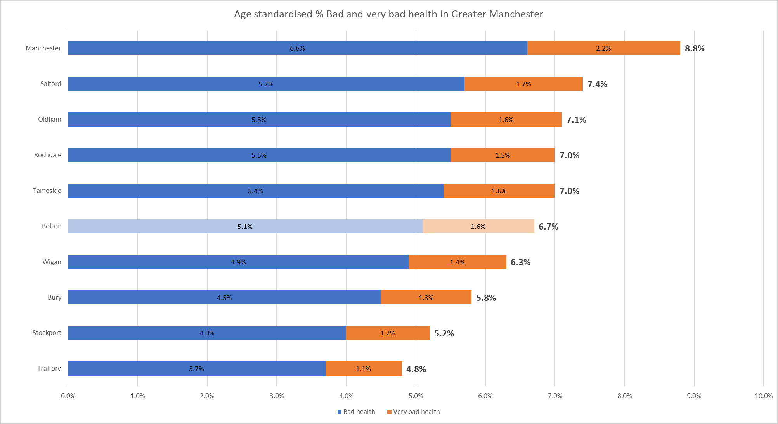

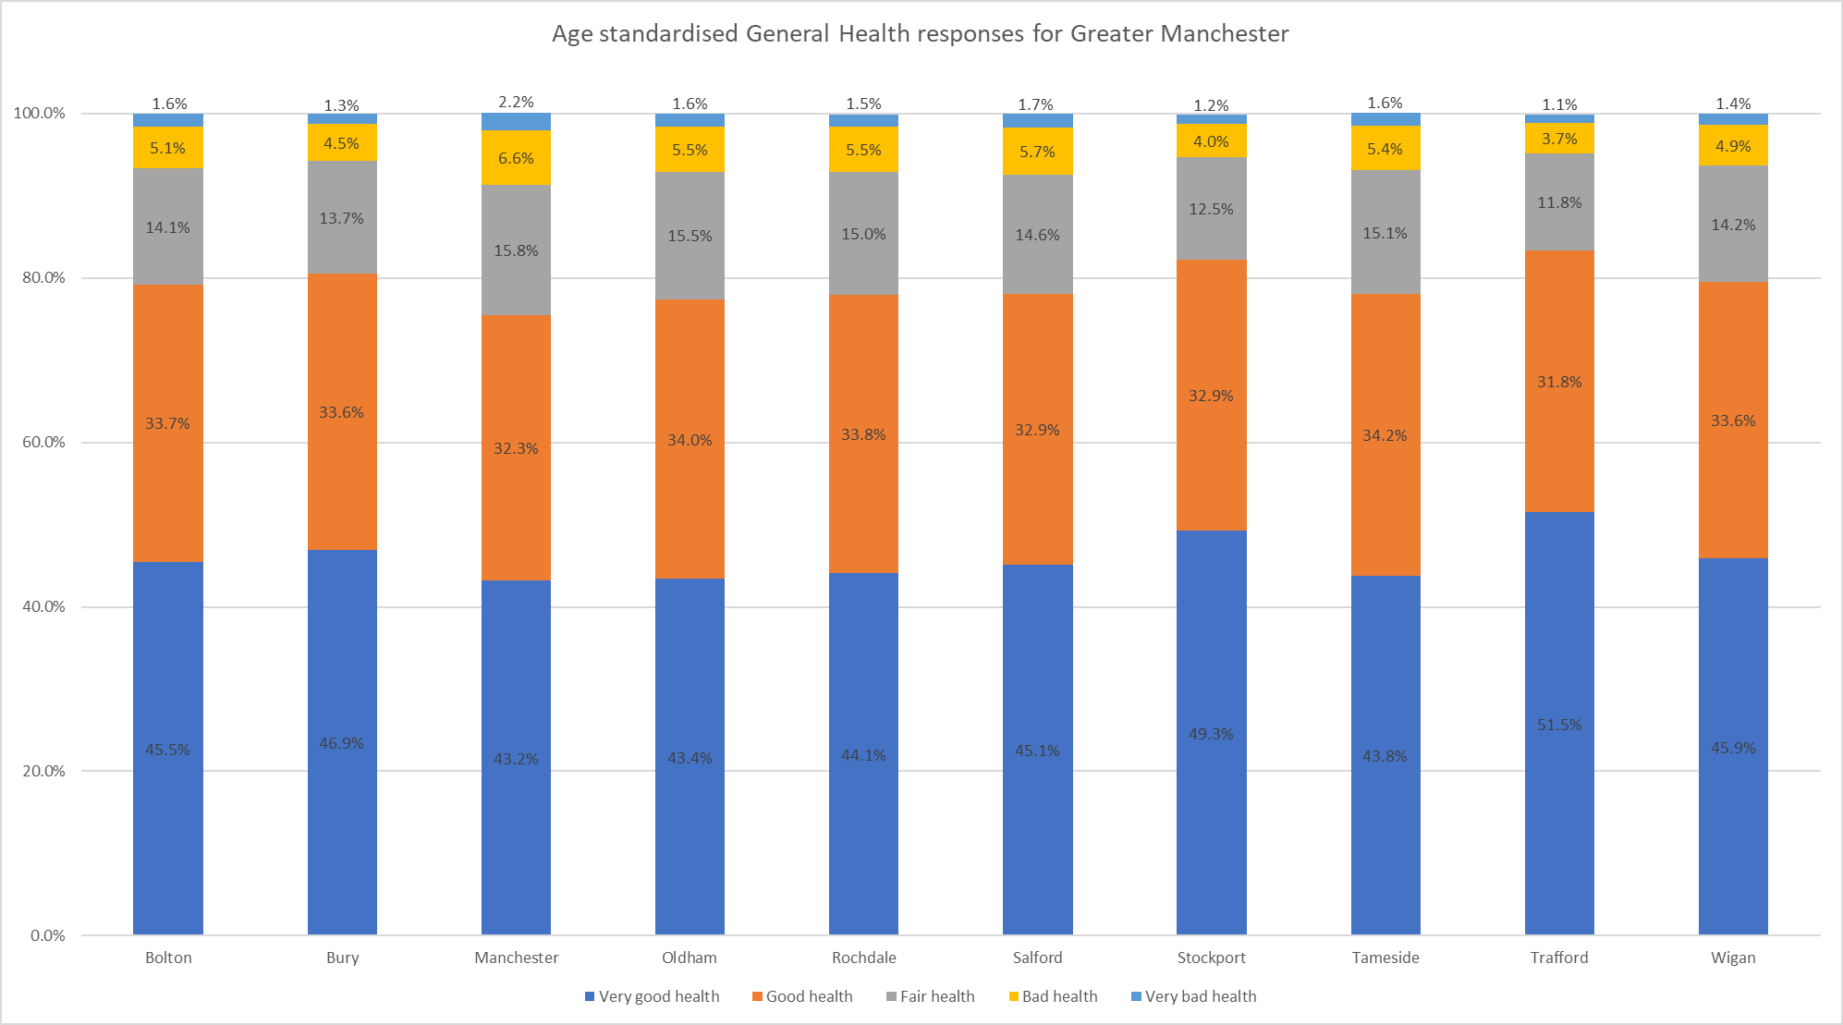

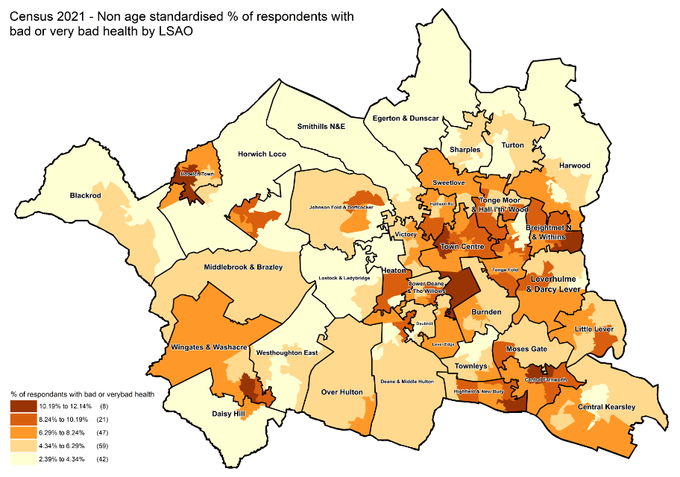

Since the 2011 census Bolton has seen an increase in the proportion of people reporting very good health from 42.2% in 2011 to 45.5% in 2021 and a slight decrease in the proportion reporting good health from 34.5% in 2011 to 33.7%. There has also been decreases in the proportion of people reporting fair health (15.8%-14.1%) and bad health (5.9%-5.1%), whilst the proportion reporting very bad health remained at 1.6% the number of people has increased from 3869 to 4229.

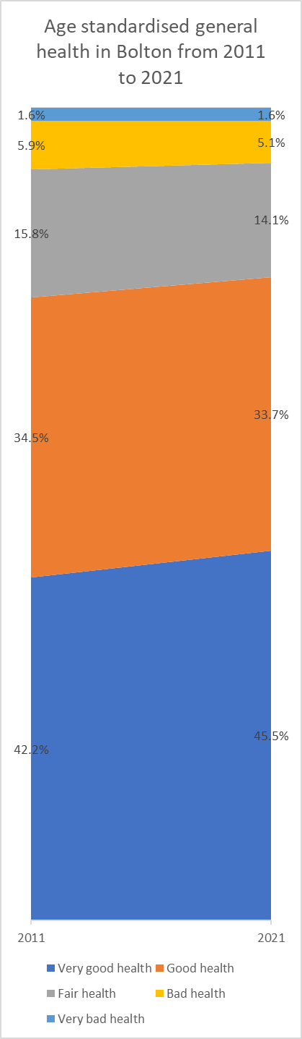

Useful links

General health, England and Wales - Office for National Statistics (ons.gov.uk)
Census Maps - Census 2021 data interactive, ONS
Build a custom area profile - Census 2021, ONS
How life has changed in Bolton: Census 2021 (ons.gov.uk)

New and notable – Bolton JSNA – this and all future census briefings will be available here with local interpretation. A working group of multi-agency partners is developing more bespoke analysis and intelligence to inform Bolton priorities

