Directorate of
Public Health

2021 Census Bolton
Summary briefing: Disability

Prepared by: Bolton Council Intelligence Hub in collaboration with BRAIN

Date: 23/01/2023

Summary briefing: Disability

Purpose
This report details the Disability Census 2021 information summary for Bolton (data release 19/01/2023).

Scope
Respondents were asked "Do you have any physical or mental health conditions or illnesses lasting or expected to last 12 months or more?". If they answered yes, a further question "Do any of your conditions or illnesses reduce your ability to carry out day-to-day activities?" was presented. The question changed from 2011 to collect data that more closely aligns with the definition of a disability in the Equality Act 2010. This change in the way disabled people are identified may have had an impact on the number of people identified as disabled.

Disability and age are closely related, with older people being more likely to be disabled. To account for different age structures in populations age-standardised proportions (ASPs) are used throughout this paper, with the exception of the data on the number of disabled people within a household. They allow for comparison between populations over time and across geographies, as they account for differences in the population size and age structure. Where numbers are reported these are the actual number who responded in each category.

Census 2021 was undertaken during the coronavirus (COVID-19) pandemic, which may also have influenced how people perceive their health status and activity limitations and therefore may affect how people chose to respond.

Key findings
In Bolton the proportion of people that are disabled has decreased by 3.1 percentage points from 22.4% in 2011 to 19.3% in 2021. The total number of respondents who are disabled under the Disability Act 2010 was 53,598. There are a further 17,579 people who have a long term physical or mental health condition that has either existed for 12 months or is expected to last 12 months, that are not disabled under the Disability Act 2010 as their day-to-day activities are not limited by their condition.

Bolton has a smaller proportion of its residents that are disabled than the North West 19.8%, and a larger proportion than England and Wales 17.8%. When compared to Greater Manchester Bolton has the 4th lowest proportion of disabled people with Manchester (22.3%) and Salford (22.2%) being the highest. Trafford has the lowest proportion of disabled people at 16.6%.

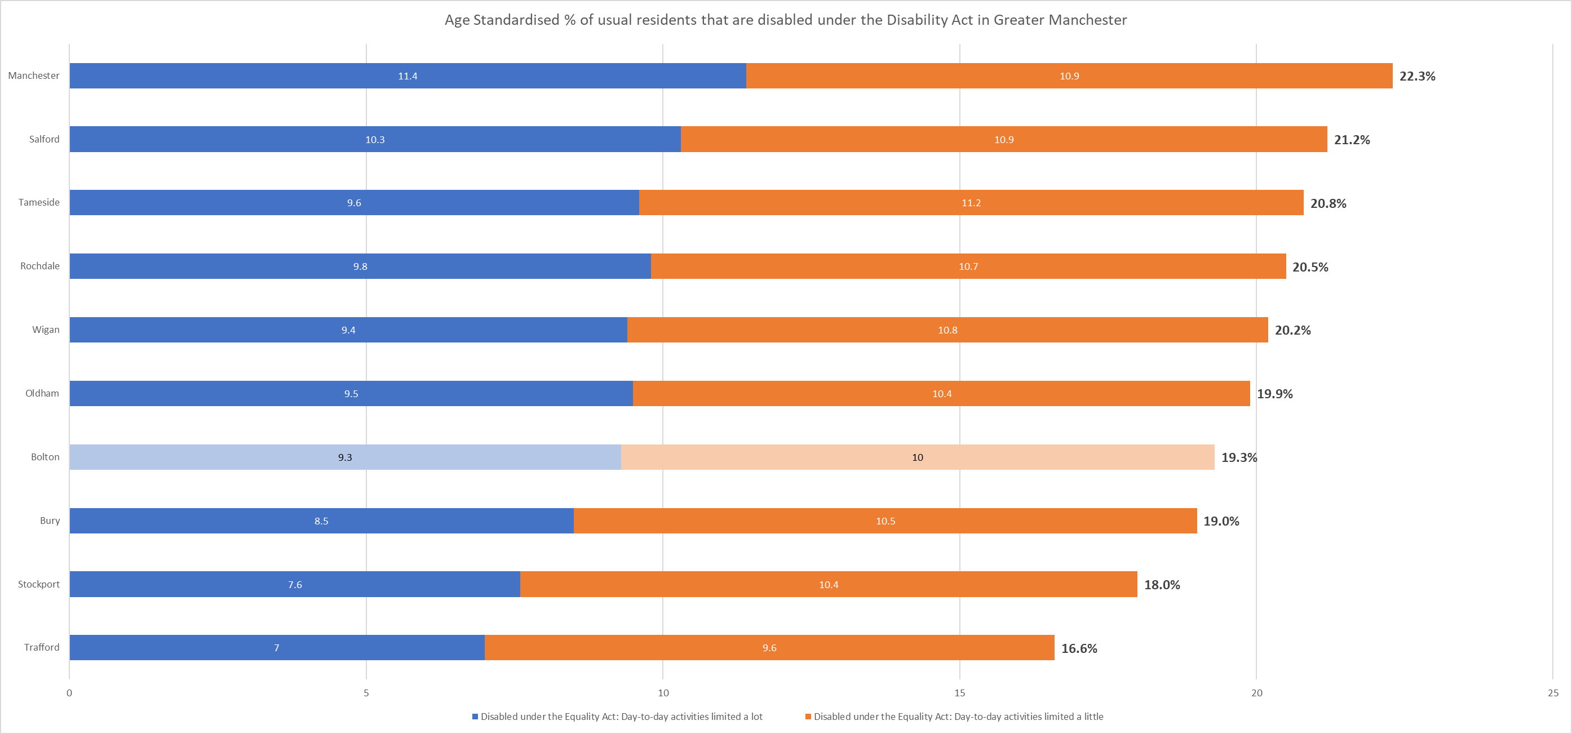

For the number of households that contain disabled people it is not possible to age standardise therefore the proportions reported in this next section are based on total responses.

There are 41,870 households in Bolton containing at least one person who is disabled under Disabilities Act 2010. The proportion of households that contain disabled people is 35.2%, with 27.9% containing one person who is disabled and 7.3% containing two or more. This was slightly higher than the figure for the North West (35%, 27.6% one person, 7.4% two or more), and higher than the figure for England and Wales (32.3%, 25.6% one person, 6.7% two or more).

Compared to it’s Greater Manchester neighbours Bolton has the 5th highest proportion of households that contain disabled people. Tameside (36.2, 28.5% one person, 7.7% two or more) and Oldham (36.2%, 28.0% one person, 8.2% two or more) had the joint largest proportion. Trafford had the lowest proportion in Greater Manchester 30.6%, 24.6% containing one disabled person and 6.0% containing two or more people who are disabled.

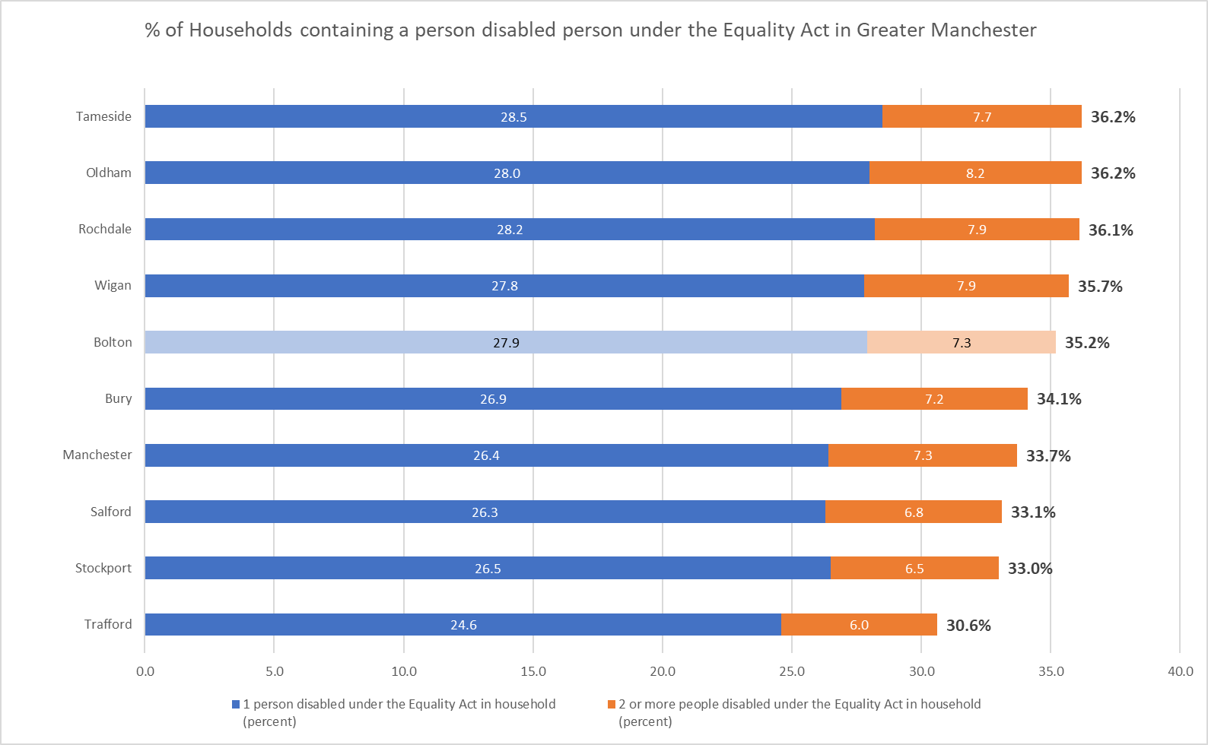
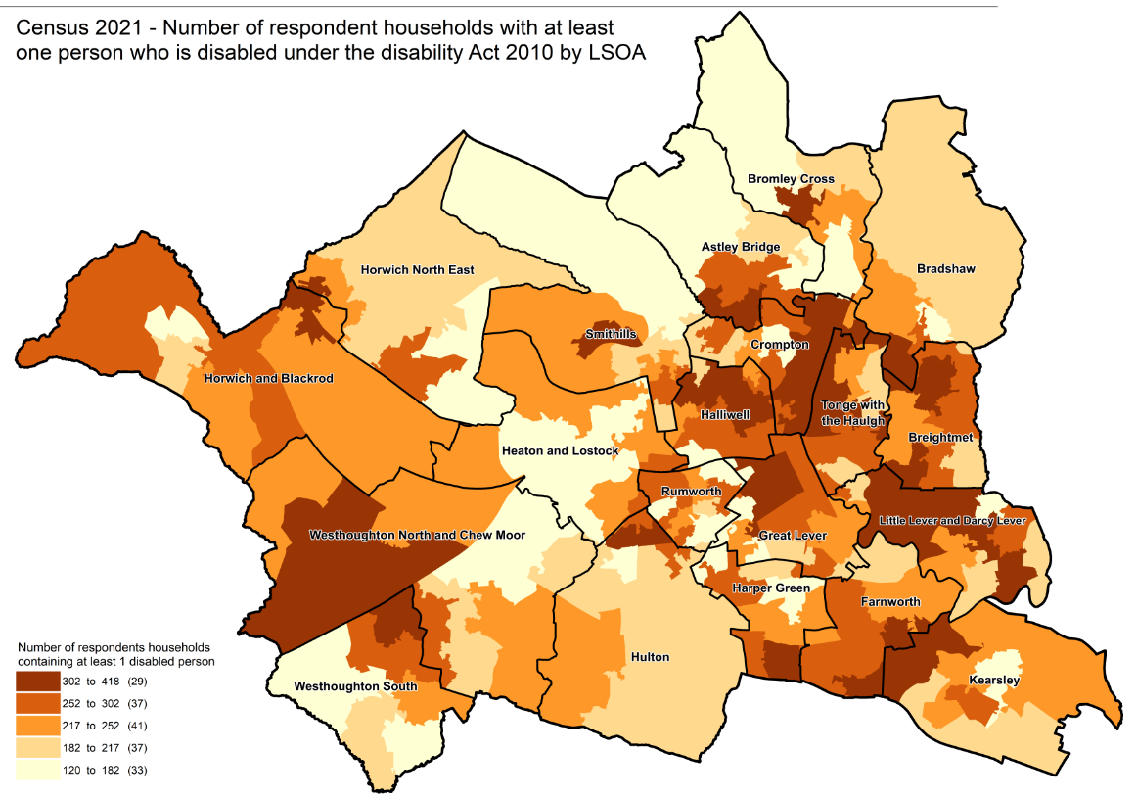

Useful links

General health, England and Wales - Office for National Statistics (ons.gov.uk)
Census Maps - Census 2021 data interactive, ONS
Build a custom area profile - Census 2021, ONS
How life has changed in Bolton: Census 2021 (ons.gov.uk)

New and notable – Bolton JSNA – this and all future census briefings will be available here with local interpretation. A working group of multi-agency partners is developing more bespoke analysis and intelligence to inform Bolton priorities

